**2.Digital Image processing Course Report:**

Vision is a major source of information for human beings. ‘ Earlier it was impossible to achieve but due to the development of new technologies it has been made possible’. Image processing has its impact on communication devices also. By digital image processing we can enhance the image , extract the text from image, edges of images can be detect and we can apply other effects also . We can get any details about the images . There are many applications of digital image processing. Almost this technique is use in every field , medical field , rorbotics., neural networking , also useful in Crime branch for investigation.

The project mainly deals with one of the application of digital image processing that is detecting edges in the images.

**1. INTRODUCTION**

1.1 DEFINATION

Digital image processing is concerned with processing of an image. Image processing is a method to perform operations on images like enhancing images, extracting text from image, detecting edge of image and many other operations. In digital image processing we take an image and convert that image in different forms. Like if we take color image we can convert it into grey image. In this both the input and output is an image. Usually Image Processing system includes treating images as two dimensional signals while applying already set signal processing methods to them.

Today, its is rapidly growing technology. It forms core research area within engineering and computer science disciplines too. Image processing has its wide applications in robotics, machine learning, neural networking, signal processing, medical field, graphics and animations and in many other fields.

1.2 HISTORY

Many techniques of digital image processing were developed in ,1960s at the Jet Propulsion Laboratory, Massachusetts Institute of Technology, Bell Laboratories, University of Maryland. The cost of processing of image was very high. But that changed in 1970s, when digital image processing grow rapidly as cheaper computer and hardware became available. Images then could be processed in real time. With the development of fast computers available in 200s,digital image processing has become one of the most common form of image processing. It is used because it is not only the most versatile method, but also the cheapest.

1.3 STAGES IN IMAGE PROCESSING

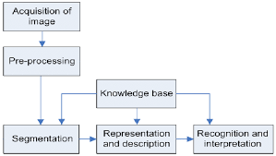

1.3 APPLICATIONS

 Almost in every field, digital image processing puts a live effect on things and is growing with time to time and with new technologies.

1. Image sharpening and restoration-

It is the process in which we can modify the image. We can convert the color image to grey image, sharpening, enhancement of the image, detecting edges, and recognition of images.

1. Medical field-

Now a days if we have brain tumor through the image processing the tumor is detect that where the tumor is. Also it is used to detect any kind of cancer.

Xray imaging, medical CTScan , UV imaging depends on the functioning of digital image processing.

1. Robot -Vision-

There are several robotic machines which work on this technique. Through this technique robots find their ways. Like they can detect the hurdle and line follower robot.

1. Pattern- recognition-

It involves study of image- processing. It is also combined with the artificial intelligence such that computer-aided diagnosis, handwriting- recognition and images- recognition can be easily implemented.

1. Video processing-

The collection of frames and pictures are arranged in such a way that movement of pictures become faster. It involves frame rate , motion detection, reduction of noise and color space conversion etc.

1.4 ADVANTAGES AND DISADVANTAGES

Advantage

1. Processing of images are faster. It require less time to process the image. There is no need of films and other photographic equipment.
2. Interactive method for detecting face, recognizing fingerprints, detecting cancer .
3. It is eco friendly process since it does not require chemicals while processing images.
4. We can change the quality of image. We can compress , enhance , quality of image produced are good.
5. Image can be made in any required format.
6. Now a days each and every book is available on the digital stage. The demand and needs of people are changing so having optimized digital book is need of todays generation so the digital image processing plays vital role in publishing world.
7. Errors in images can easily be rectified.
8. It analyse blood cells and their composition in our body.
9. Through this technique robots can detect their visions.
10. Its also helps in pattern recognition.

Disadvantage

1. It is more time consuming.
2. It is cost effective.
3. More complex program are required for implement digital image processing.

**2. SOFTWARE REQUIREMENT SPECIFICATION**

2.1 INTRODUCTION

This section defines the project plan for ‘EDGE DETECTION OF IMAGE’. The functionality of the system, scope of the project and other information about specifications is included in this

plan.

2.1.1 Purpose

The purpose of this software is to take the input image and detect the edges in that image.

2.1.2 Intended Audience

It is an interactive system whose basic data element is an array that does not require dimensioning. This allows you to solve many technical computing problems, especially those with matrix and vector formulations

2.1.3 Intended Use

This software can be use to develop any application using different algorithms, data analysis, medical field, scientific and engineering graphics, solving mathematical problems using functions

2.1.4 Scope

The scope of software is vast. It can be used for designing video, electric circuits. Can be use in medical industry , automobile industry.

2.1.5 Definition and acronyms

MATLAB – Matrix Laboratory

###### 2.2 OVERALL DISCRIPTION ABOUT SOFTWARE “MATLAB”

For implementing digital image processing we can write code in any language like python, java and any other language. We can also use the software ‘MATLAB’ which offers lots of feature to programmers for exploring their imagination and can make any projects related to digital image processing by using their coding skills.

Some features of MATLAB are:

1. It has several in built commands and math functions that help in performing mathematical calculations.
2. It also provides an interactive environment for design and problem solving.
3. MATLAB features a family of add on application specific solutions called toolboxes. Toolboxes allow us to learn and apply special technology.
4. We can add toolboxes for signal -processing, control -systems, neural- networks, and many other areas.
5. It has facilities for displaying vectors as graphs, and printing these graphs.
6. It include high level function for two dimensional and three dimensional data visualization, image processing,and presentation graphics.
7. We can create GUI with the help of GUI guide to make our project more effective.
8. GUI guide contains many inbuilt functions through which we can make many unintrols like pushbutton, toggle buttons, lists , checkboxex, axes.
9. It provides many functions and algorithms with external applications and languages such as C, Java, .NET .
   1. SYSTEM REQUIREMENTS

The software requires the following to be in the system.

2.3.1 Toolboxes

* + 1. Minimum 5GB space required

**3. SOFTWARE DESIGN**

* User interface

This prototyping of this GUI is done with the help of GUI Guide.

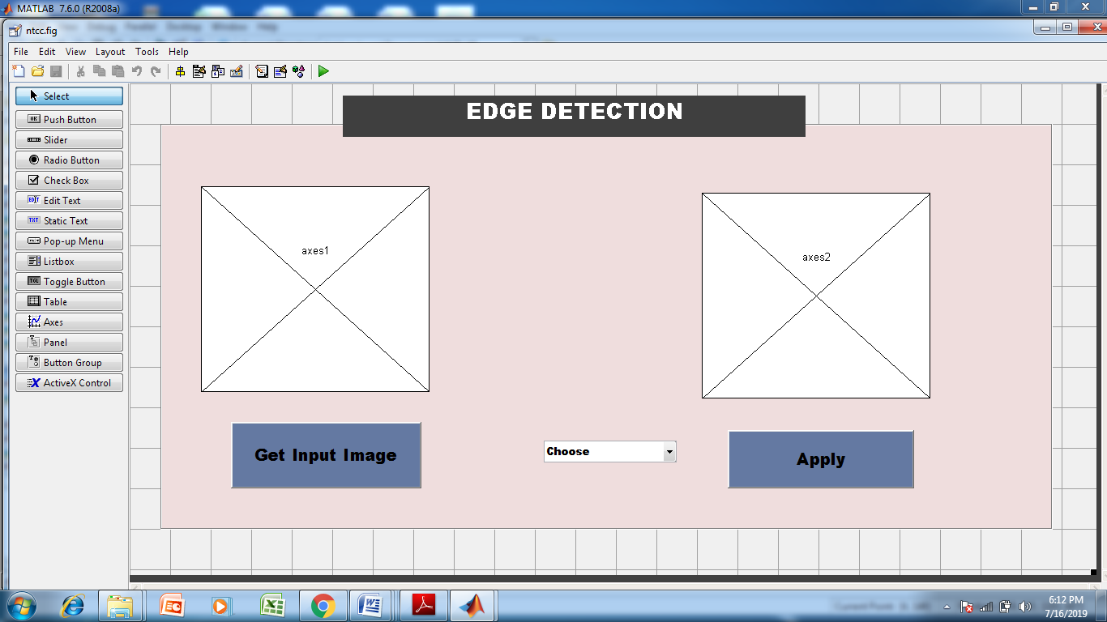

Fig 1 designing of GUI

* After creating the above GUI , the image is taken as input
* Convert the coloured input image in gray scale image.
* From the list choose the suitable edge detector of your choice and click on apply button.
* Final image which detect the edges in the input image.

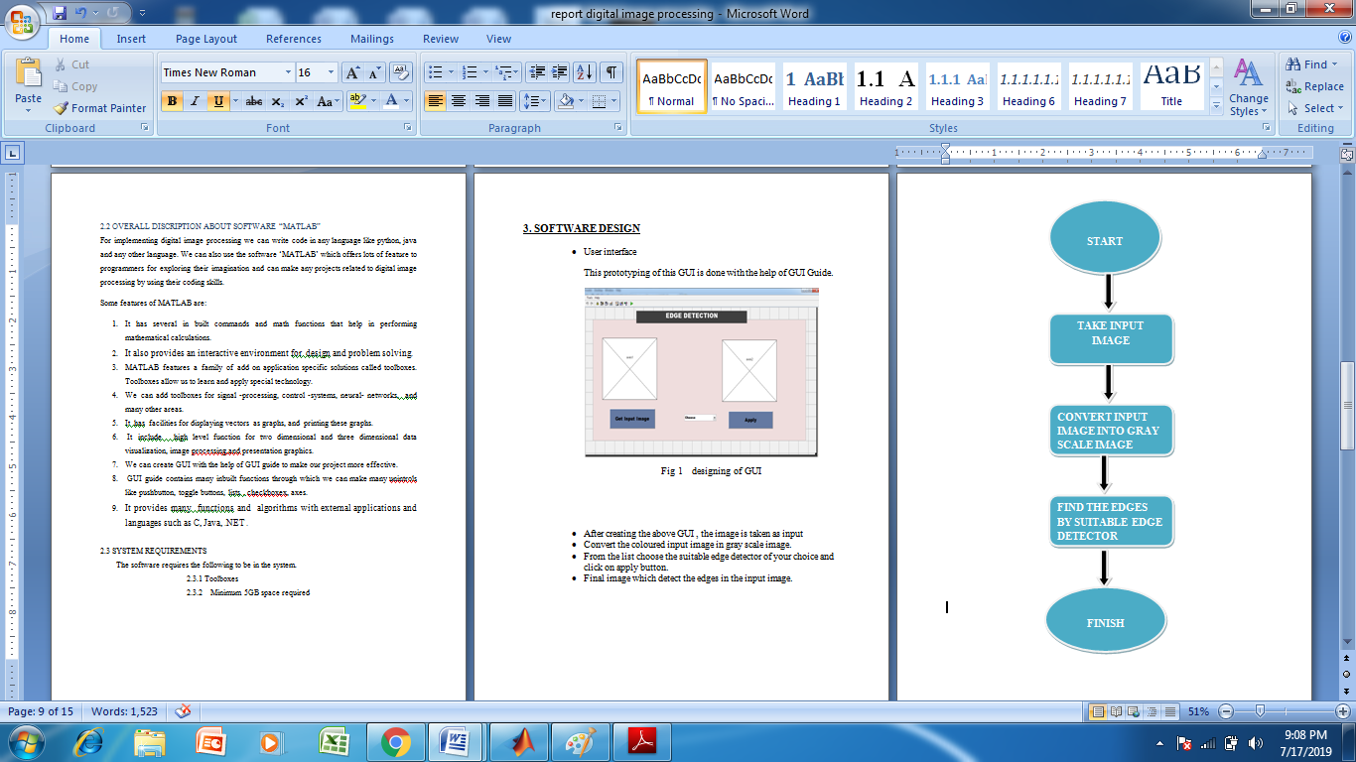

**4. SOFTWARE TESTING**

4.1 The edges must be detect in image using different edge detecting operator

The image in MATLAB database must be correctly detect the edges in the input image.

Test steps:

1. Click on the get input image button.
2. Now choose any of the operators from the list box and click on apply button.
3. Check the output image.
4. If you does not choose any option by default the grayscale image will be displayed.

Result: The edges should be detect in the input image.

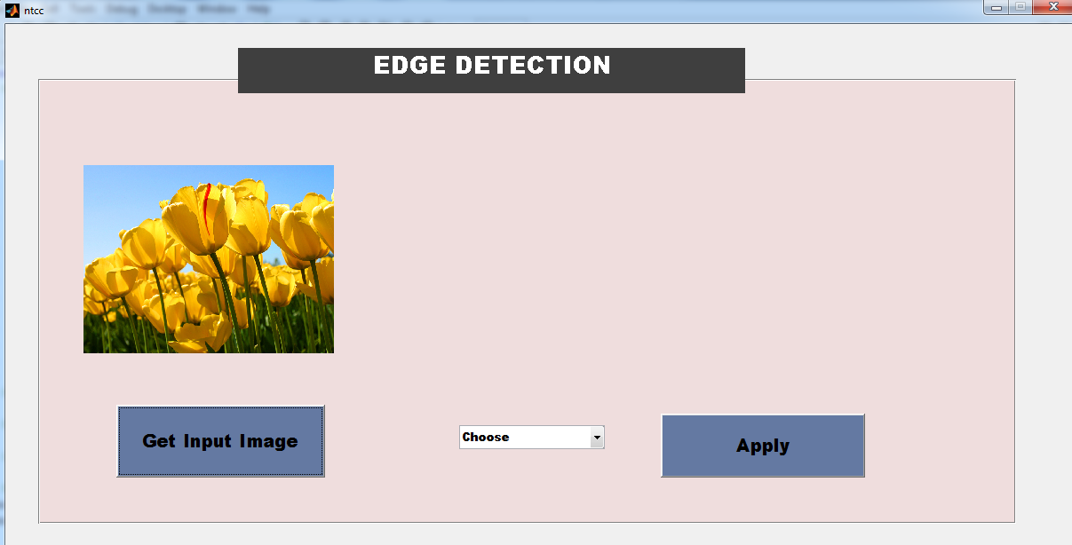fig 2 input image

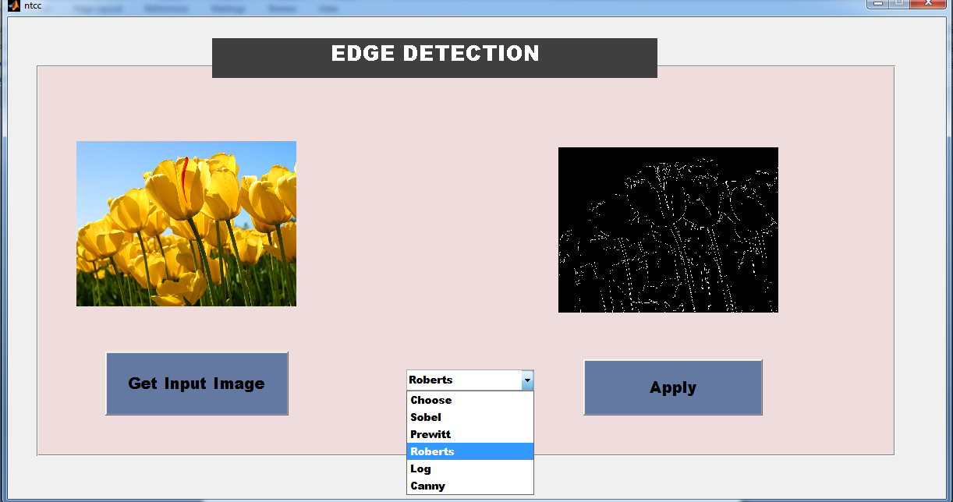

Fig 3 Apply any operator

 

Input Image Gray Image

 

Sobel Prewitt

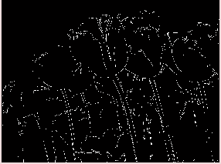 

Log Canny

**5.CONCLUSION**

In a discpline of computer vision digital image processing is becoming popular day by day.

Edge detection is the initial step of recognizing object. Edges describe the boundaries of the object that is useful for identification of objects that are presented in the scene such as X-ray image. Edge detection is mostly use in image – segmentation . But all the edge detection techniques are not same. They are different from each other. In this paper we have made attempt to detect the edges in the input images using different methods. This different edge detection technique is implemented through the software ‘MATLAB R2008a’. It has been observed that canny edge detection is more superior than prewitt , sobel , log , roberts edge detector.

6.1 Advantages and disadvantages of edge- detectors

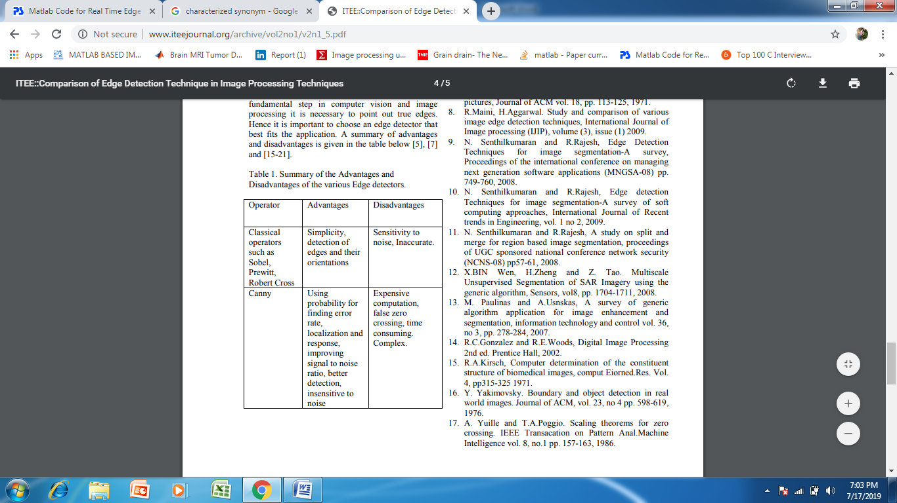

**6. FUTURE SCOPE**

Due to the fast development in the computer technology , future of the image- processing is going to be more flexible. Digital image processing has wide range of applications. In future it has been expected to be less expensive. Due to advancement of this technology there will be millions of robots in world. Advances in the image- processing and artificial intelligence will involve spoken commands, translation of languages, recognizing the finger prints, tracking of people and things, diagnosing medical conditions, performing surgery and automatically driving all forms of transport. With an increasing power of modern computing, the concept of computation can go beyond the present limits and in future, image processing technology will advance . The future trend in remote sensing will towards improved sensors that record the same scene in many spectral channels. Graphics data is becoming important now a days in image processing app1ications. In future image processing technique will play import role in space also.